A CRM APPLICATION FOR WHOLESALE RICE MILL

1) Introduction To Salesforce

What Is Salesforce?

Salesforce is your customer success platform, designed to help you sell, service, market, analyze, and connect with your customers.

Creating Developer Account

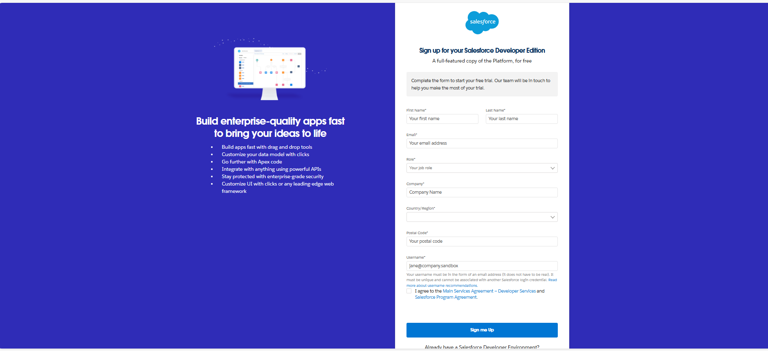

Account Activation

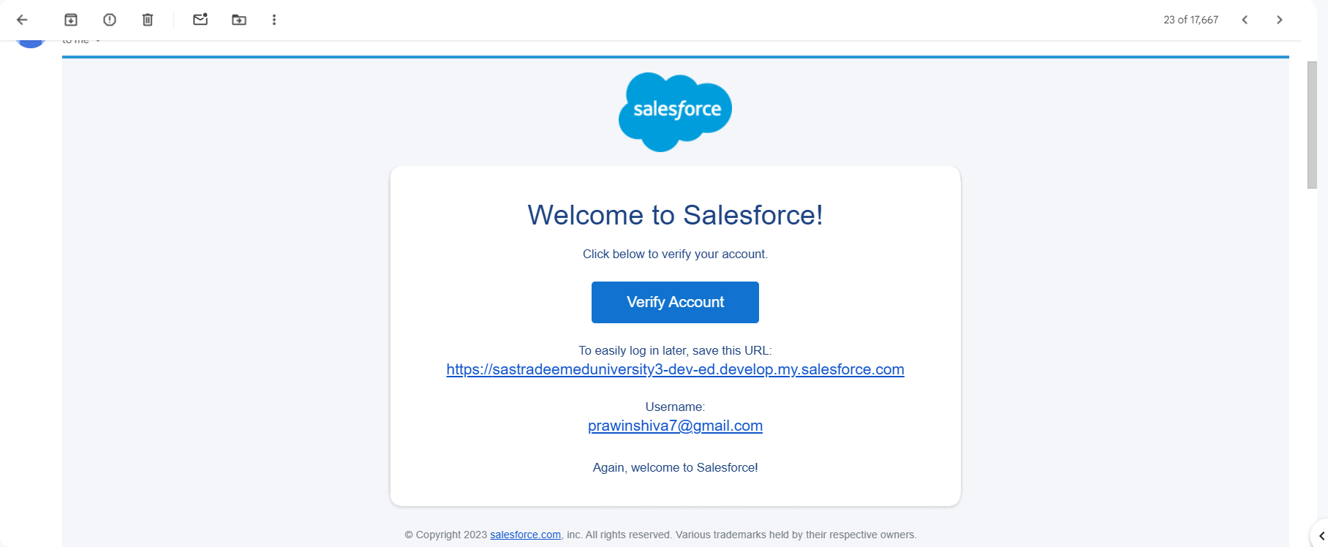

2) Object

Supplier Object

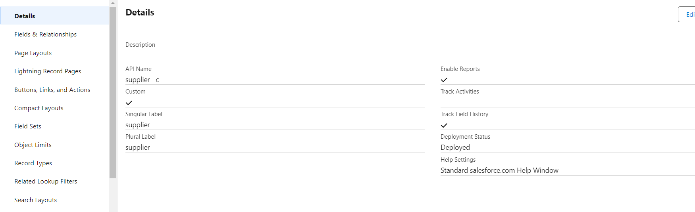

Consumer Objects

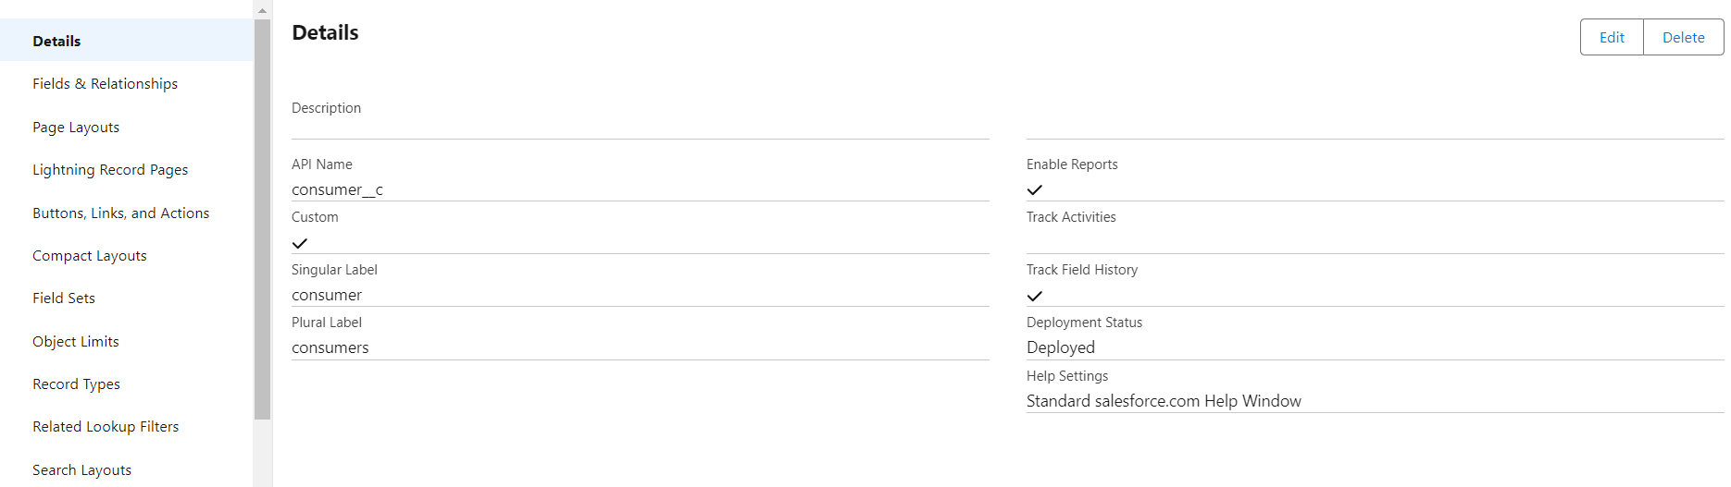

Rice Mill Object

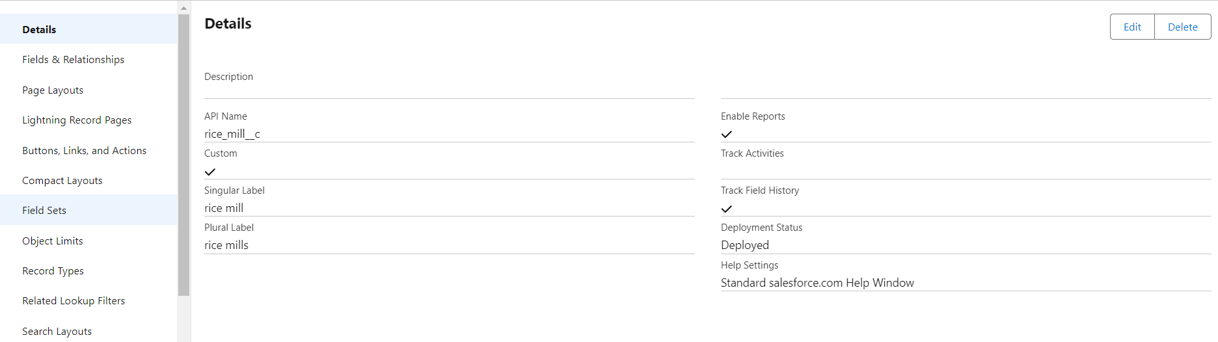

3)Tabs

Custom Tab

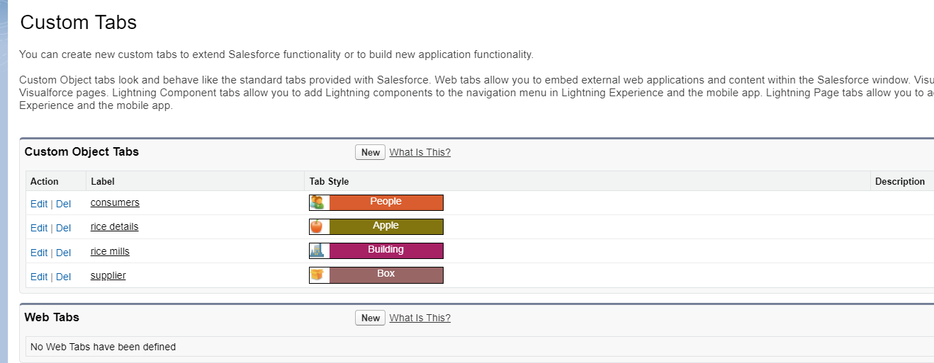

### Create A Lightning App

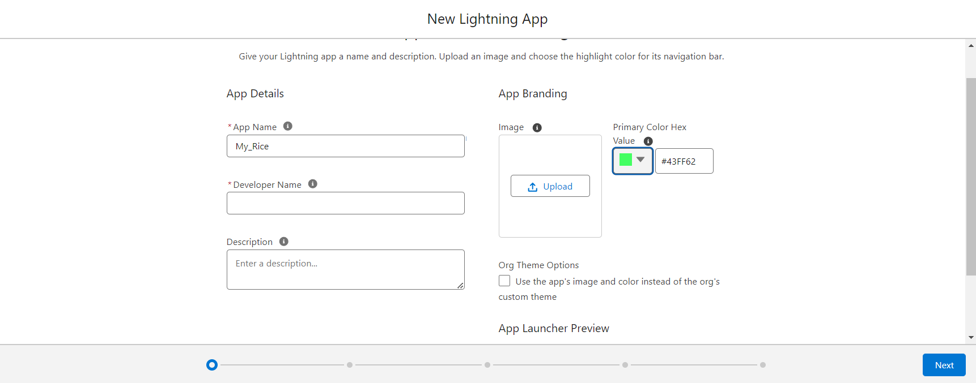

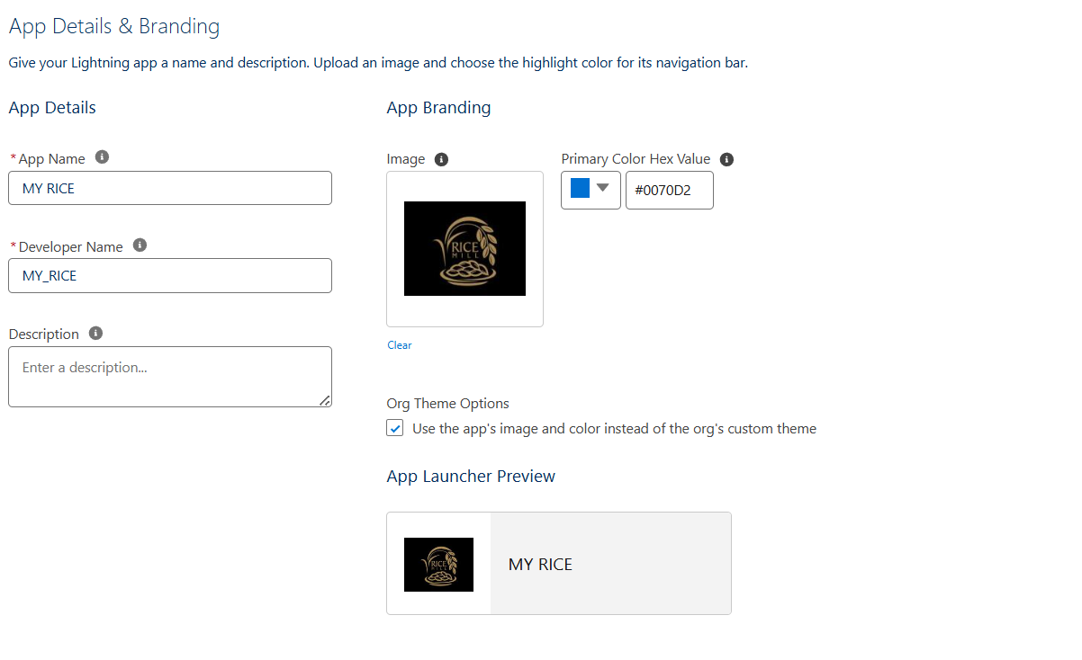

Field In Rice Details Object

Rice details

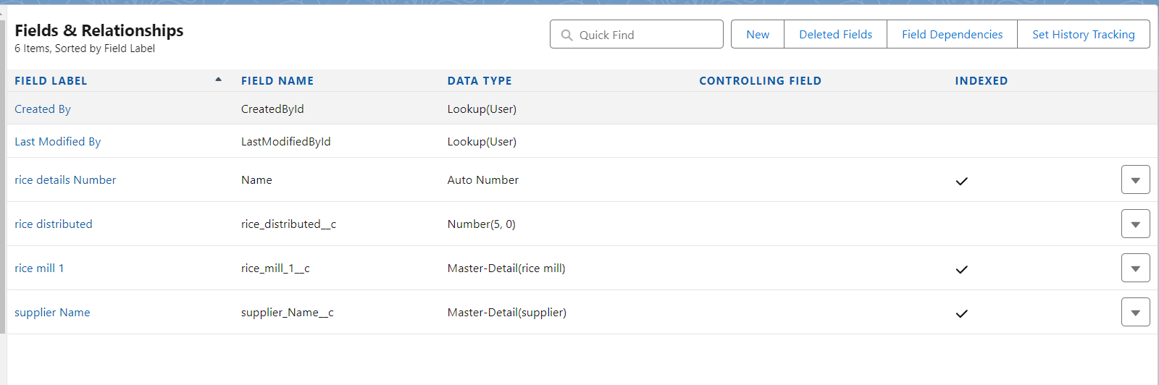

Creating Junction object

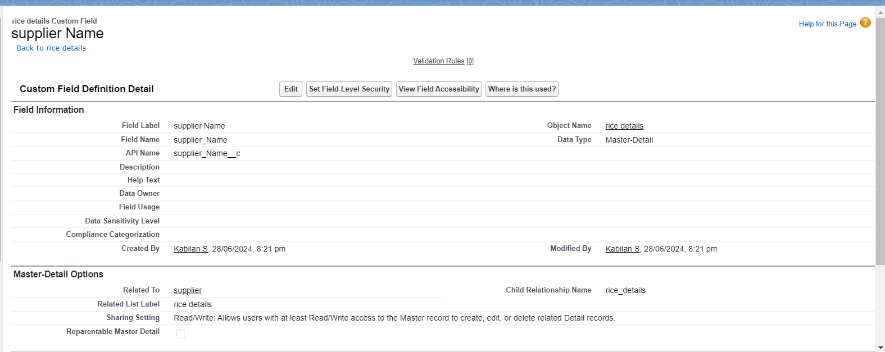

Creating Master Detail Relationship

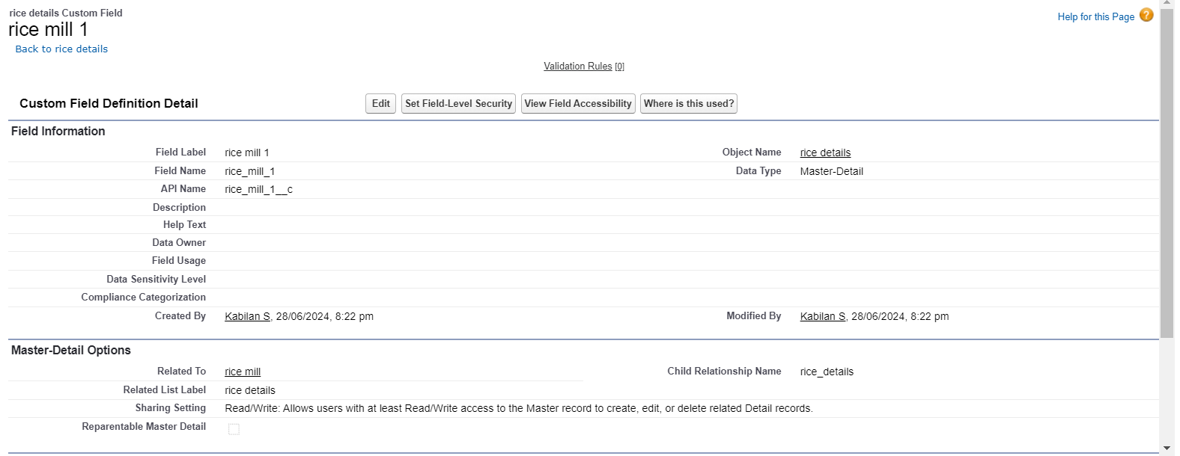

Creating The Roll-Up Summary

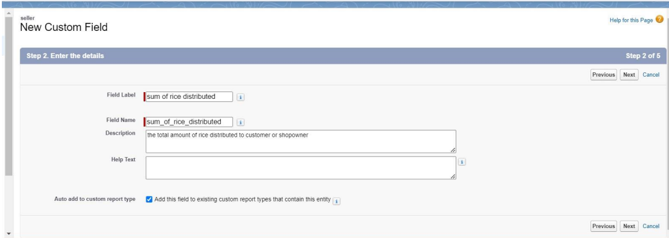

Creating Fields In Objects

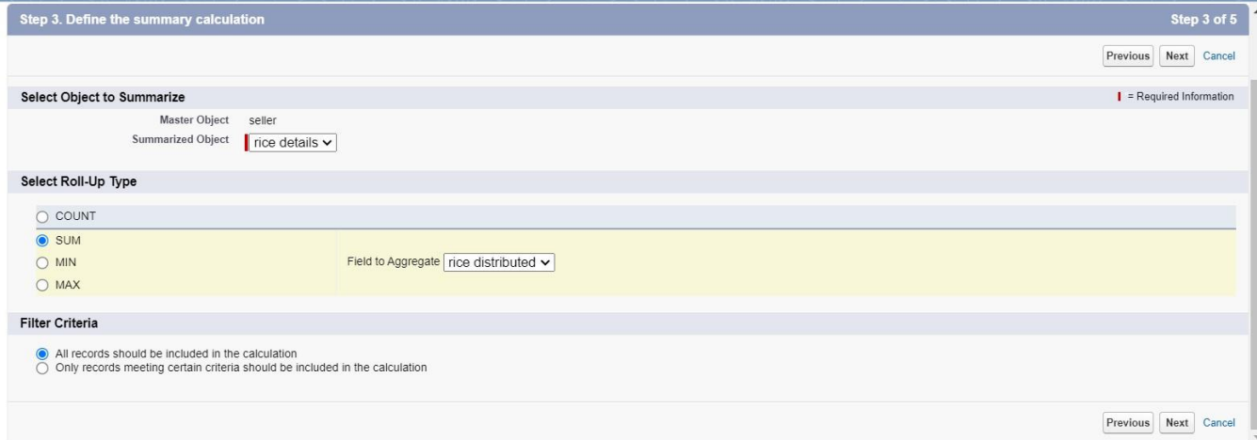

Creating Fields In Rice Mill Objects

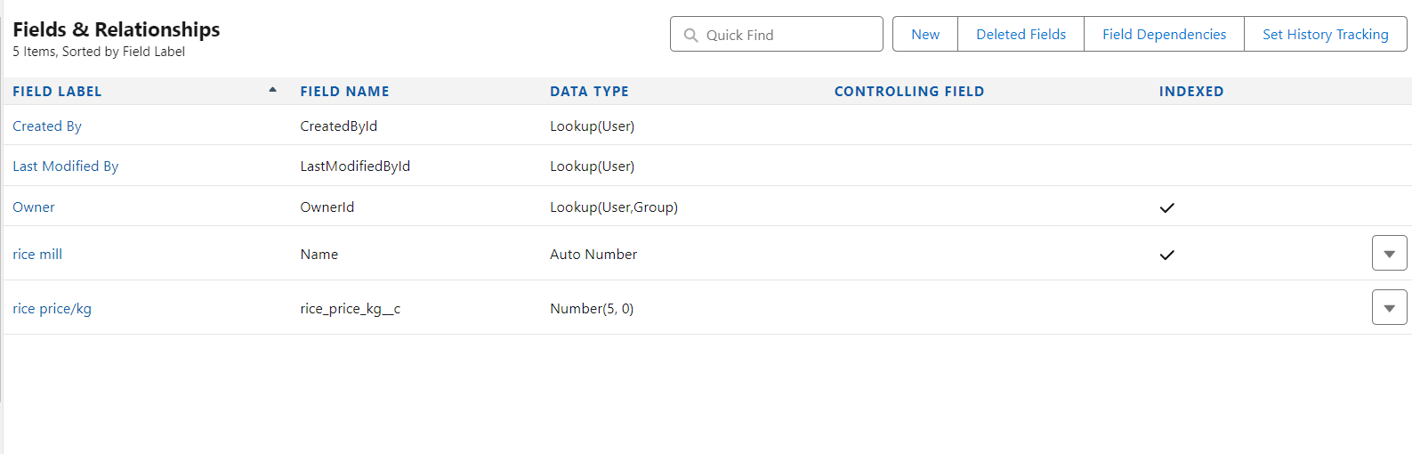

Creating Fields In Consumer Objects

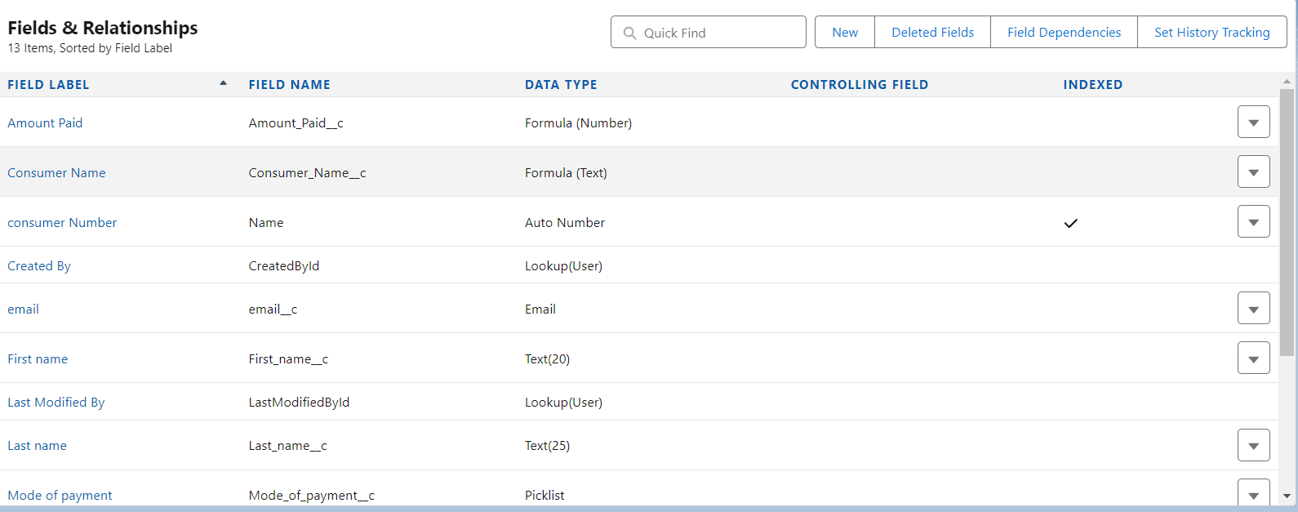

Creating The Validation Rule

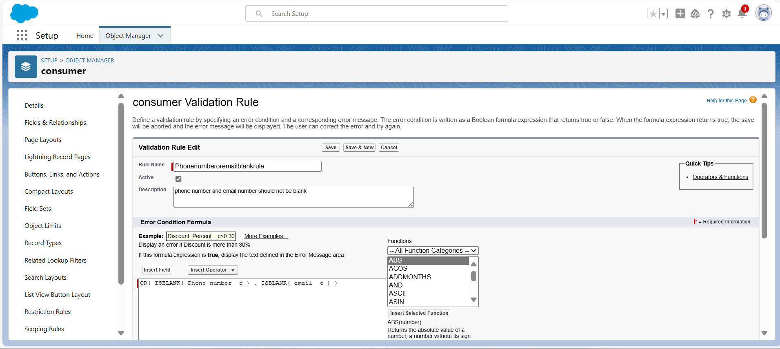

**Page Layout**

Creating The Page Layout

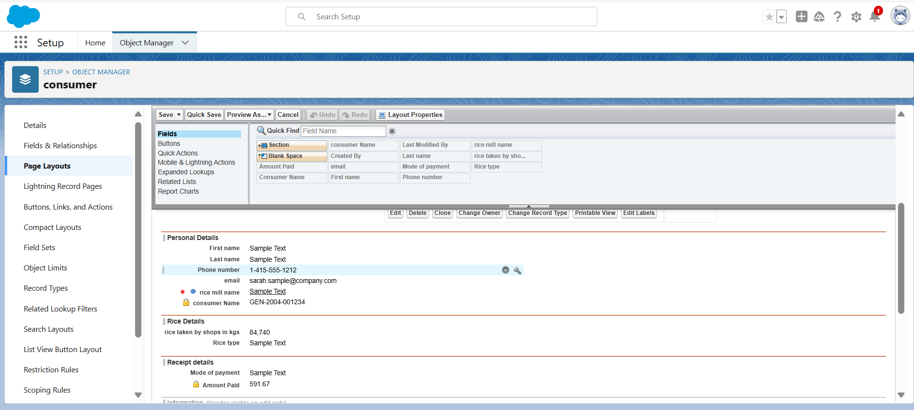

### Profiles

Owner Profile

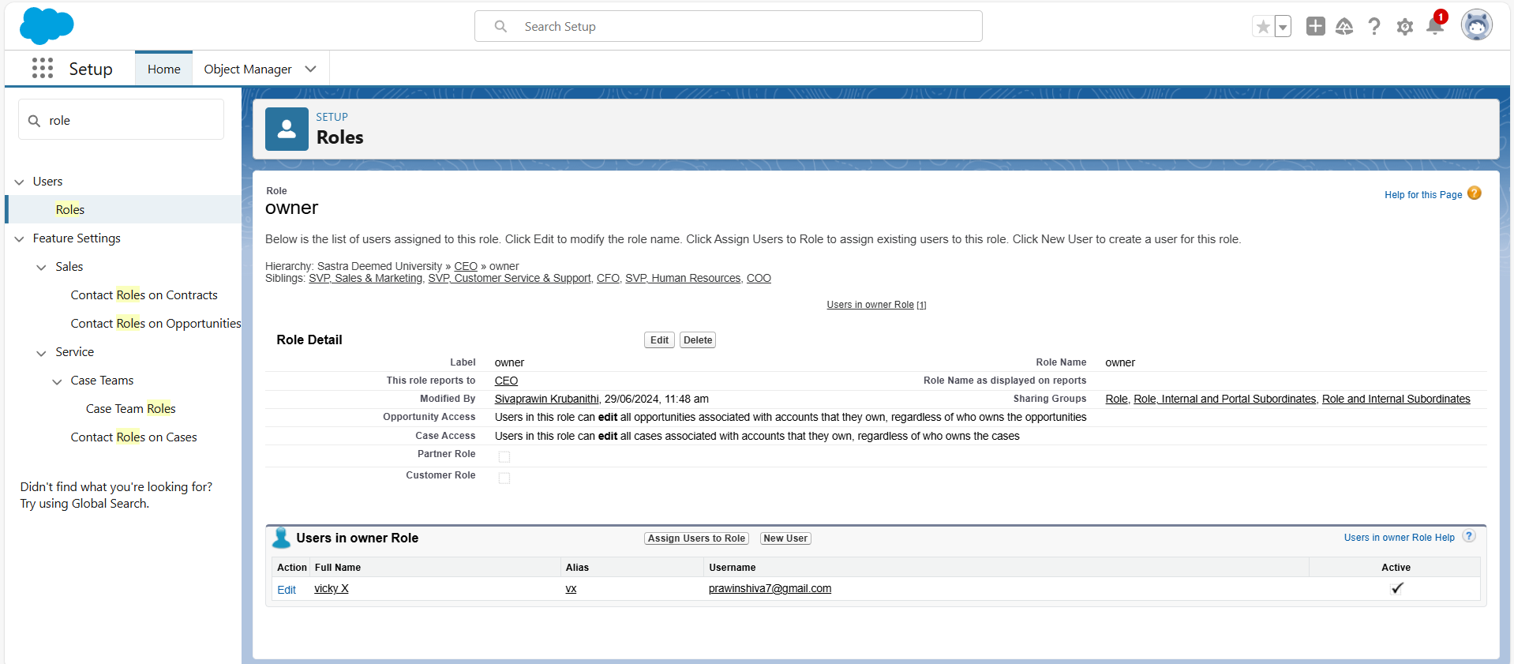

**Employer Profile**

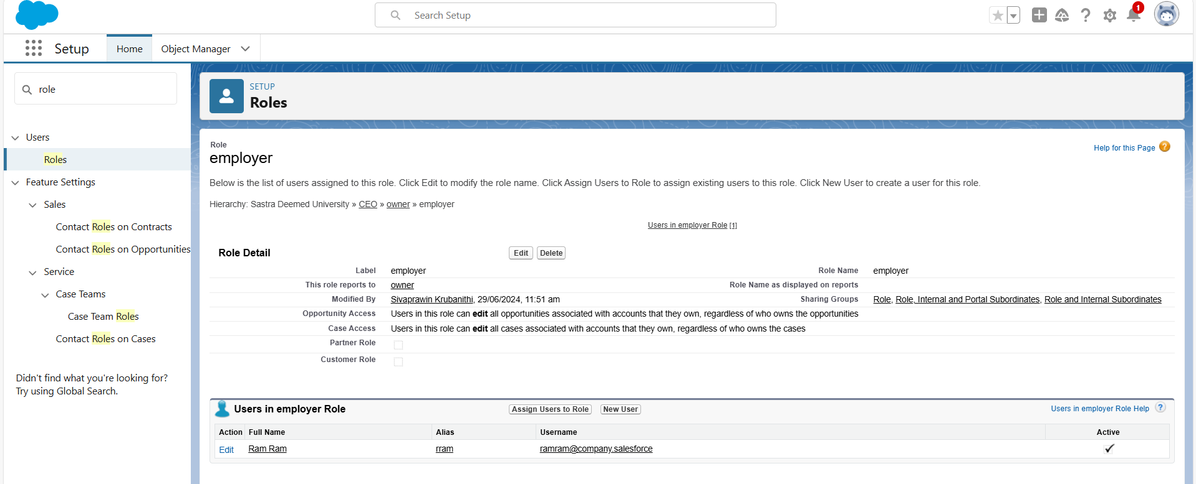

Worker Profile

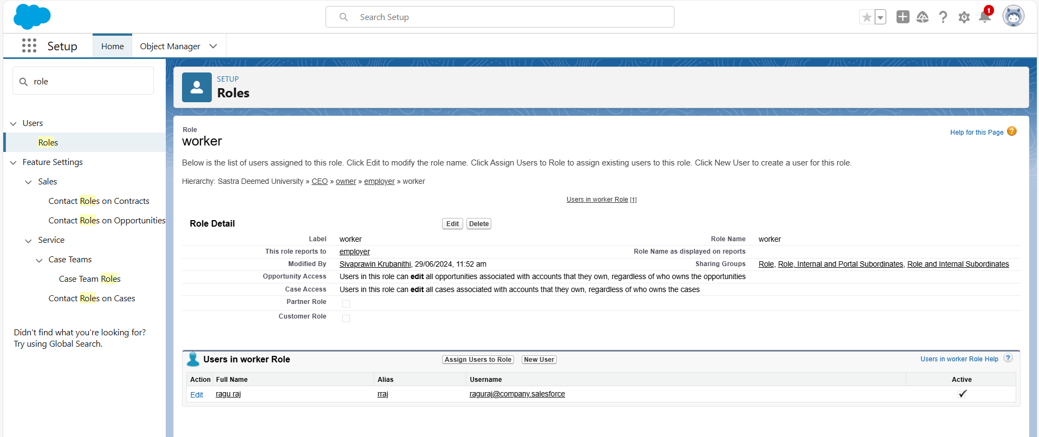

### Role & Role Hierarchy

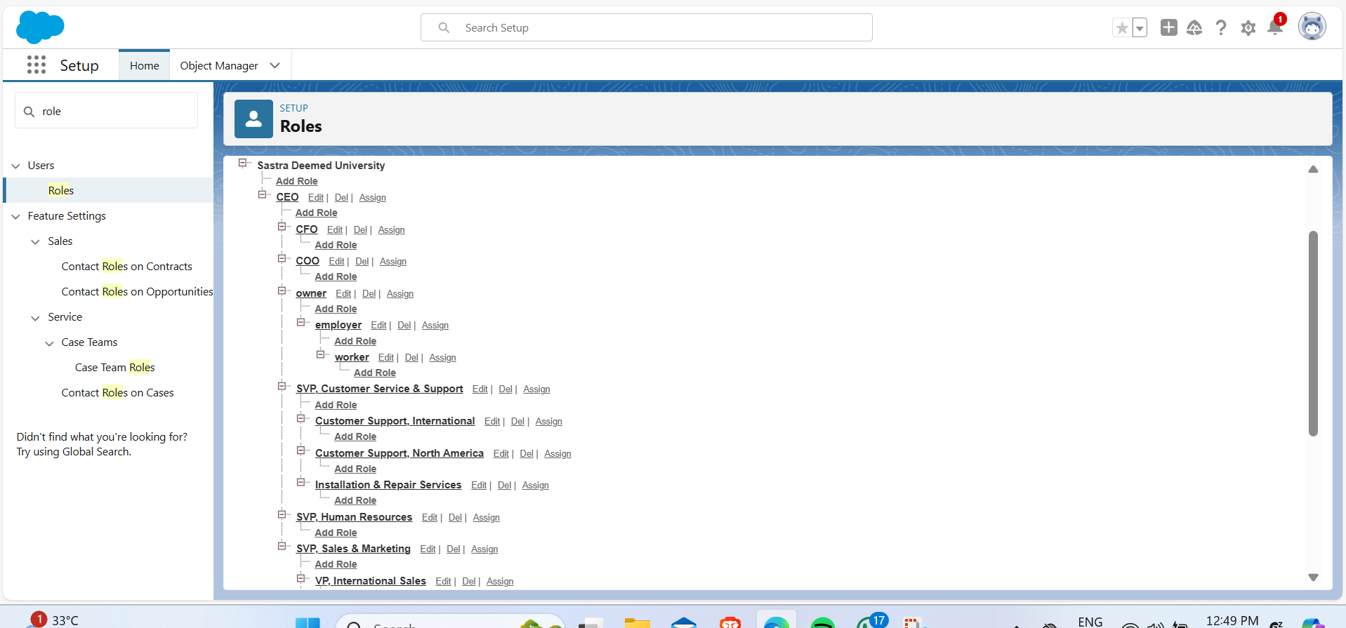

### Users

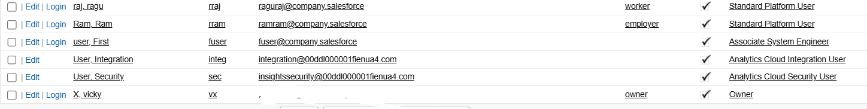

### Permission Sets

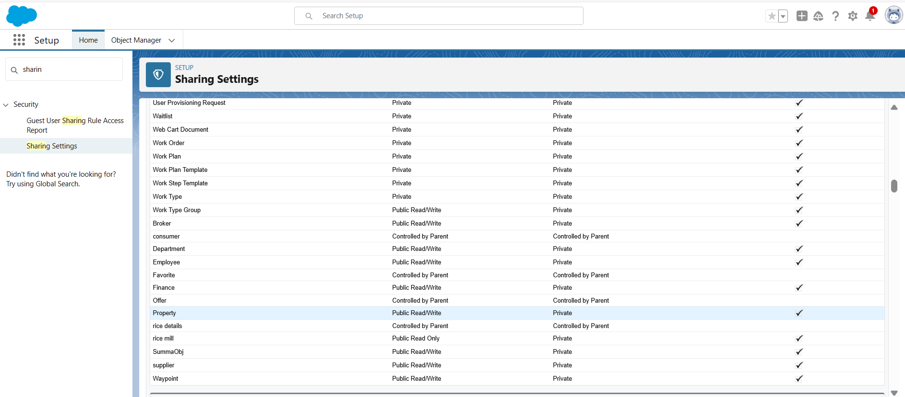

### Reports

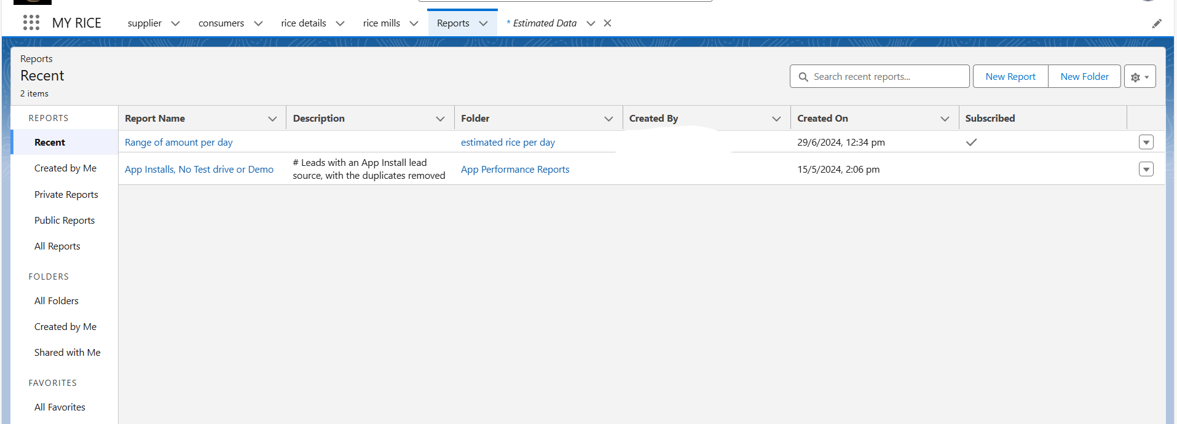

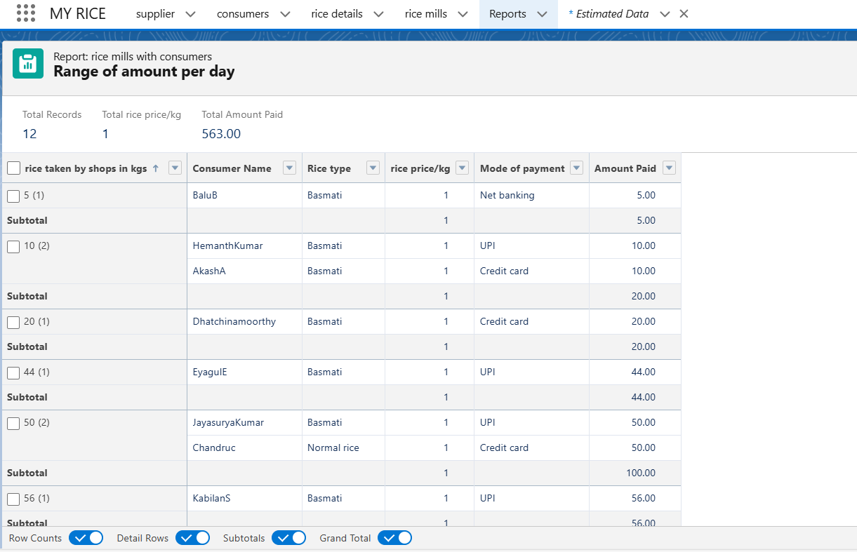

### Dashboards

